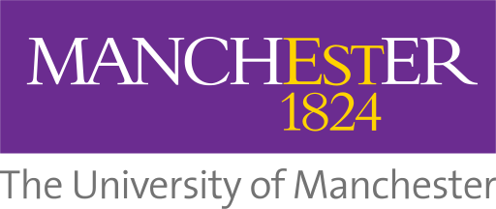
Science Communication International Summer School 2018.
University of Manchester.

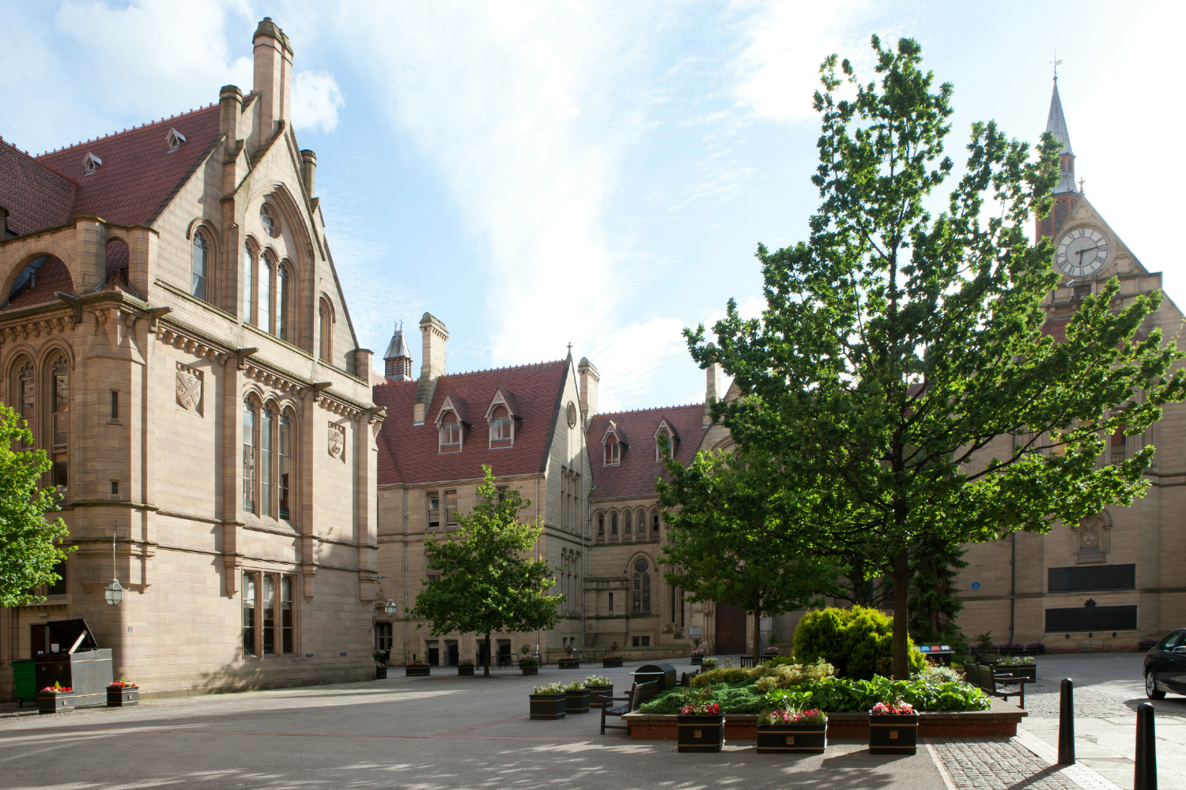

Overview:
The purpose of this summer school is to introduce participants to the field of science communication in the world-class, historically significant research environment of the University of Manchester. It will engage participants in the wide range of science communication skills developed and practiced in the city.
During the school, participants will be given the chance to experience the extensive science communication sites and resources available in and around Manchester. They will be given the opportunity to investigate some of the most exciting scientific developments currently being pursued via a range of lectures and field trips. These will be complimented by hands-on workshops, during which participants will acquire key science communication and English language skills. Participants will develop their own science communication projects, which will demonstrate their new-found abilities to colleagues and prospective employers. Attendance at the school would be an ideal foundation for those interested in pursuing a Masters in Science Communication at the Centre for the History of Science, Technology and Medicine at the university.
Week 1:
Foundations of Science Communication.
The first week will introduce participants to science communication as it has developed in Europe since the 1600s. We will investigate historically distant techniques of storing and transmitting knowledge such as the illustrating and copying of manuscripts, and trace the emergence of science as a distinct calling through nineteenth-century communication technologies such as steam-driven printing presses and magic lanterns. We will visit local sights of historical interest, such as the John Rylands Library and the Museum of Science and Industry, and witness a nineteenth-century printing press in action. Participants will be invited to practice historically significant communication techniques, and will consider the broad range of ways in which what is known has been constrained by how knowledge is transmitted.

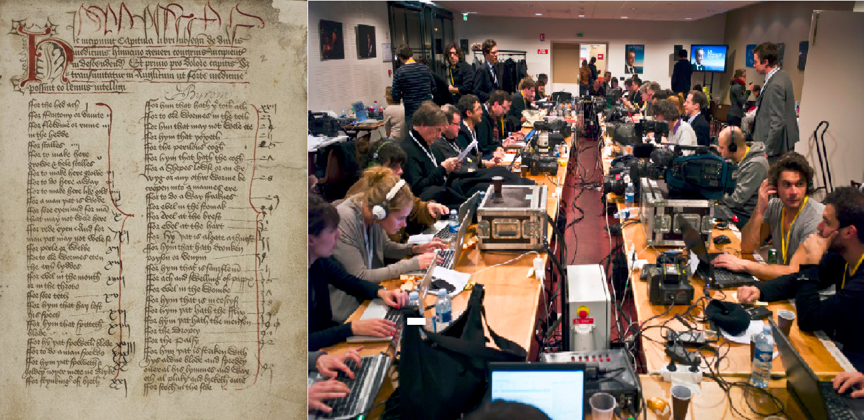

Week 2:
Introduction to Skills and Practices of Science Communication.
During the second week, participants will discover and practice contemporarily significant science communication techniques. We will investigate the range of science communication centres in and around Manchester including the Manchester Museum, the Eureka! National Children’s Museum, and the BBC. Practical workshops will address the multiple means by which science can be communicated using objects, written articles, film, games, and sound recording. Participants will thereby begin to consider how, in which contexts, and for which audiences different communication techniques can be most effective.

Week 3:
Investigating Science in Manchester.
In this week participants will investigate science as it is being pursued in present-day Manchester. We will hear from representatives of leading scientific research themes in the city, and visit University of Manchester research facilities. Participants will be introduced to sites such as the national radio astronomy centre Jodrell Bank, the Centre for Atmospheric Science, the Cancer Research UK Institute, and the National Graphene Institute. They will also be given the chance to have a personalized ‘avatar’ or 3D scan made of their bodies. By the end of the week, participants will have gained insights into key scientific research themes being pursued in the city, and begun to develop their own interests in communicating these themes.

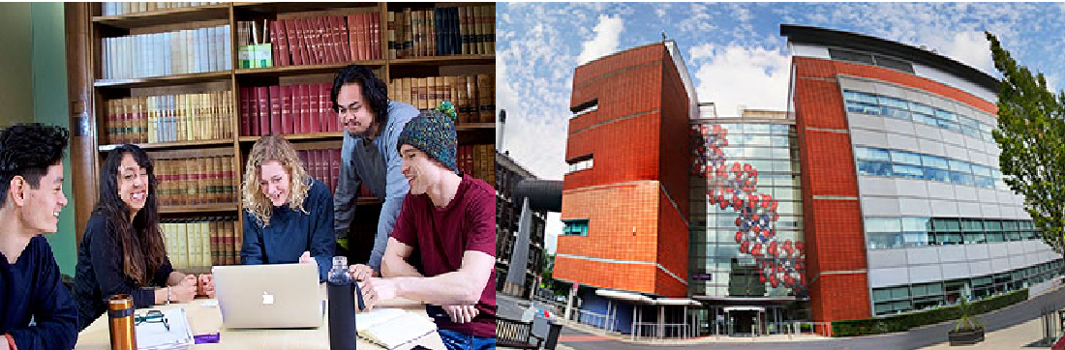

Week 4:
Communicating Science Project.
During the final week, participants will produce a range of materials based on their experiences of Manchester science. This week will bring the skills and knowledge learned in the previous sessions to bear on practical problems of science communication. We will consider how the latest scientific studies can be explained and passed on to different audiences: for example, how might a cancer research project be communicated to groups of schoolchildren? How might developments in climate science be conveyed to politicians? In what ways might the mechanisms of radio astronomy be made interesting to an audience of older people? In addressing such questions practically, participants will utilise media such as sound recording, film, blog posts, found objects, and visual design materials to produce narratives and presentations tailored to a specific audiences. They will thereby produce tangible evidence of their experiences and abilities as science communicators that will be of assistance to them in their future academic and professional careers.

[images sourced from:
https://jobs.newscientist.com/en-gb/article/a-question-of-money/
https://luna.manchester.ac.uk/luna/servlet/detail/Man4MedievalVC~4~4~514643~117357:Medical-recipes?qvq=w4s:/what%2FMedicine--History%2Fwhen%2F15th-16th%2Bcentury%2F&mi=7&trs=139#
http://www.symposium-magazine.com/science-journalism-and-the-art-of-expressing-uncertainty/
https://www.alc.manchester.ac.uk/english/study/courses/]
https://www.bmh.manchester.ac.uk/study/research/experience/

